Project Title: Rising Waters: A Machine Learning Approach to Flood Prediction
Name of the student: Gundigi Poojitha
Roll no: 232G1A3385
Name of the college: Anantha Lakshmi Institute of Technology & Sciences
INTRODUCTION
Rising Waters is an intelligent Machine Learning-based web application developed to predict localized flood risk and hazard possibilities. The system helps concerned authorities and disaster management teams make faster, more accurate, and data-driven emergency mitigation decisions by analyzing meteorological parameters and predicting whether an area faces high probability flood alerts or remains safe.
The application leverages historical open-source weather data collected from platforms like Kaggle and evaluates multiple Machine Learning classification algorithms—including Decision Tree, Random Forest, K-Nearest Neighbors (KNN), and XGBoost—to isolate the most reliable ensemble model configuration. The optimal trained pipeline is serialized into an active model object file (`xgboost_flood_model.pkl`) and integrated into an interactive Flask web application server, providing real-time risk evaluation metrics.
The system dynamically analyzes an assortment of critical environmental parameters, including annual precipitation levels, regional cloud visibility ratios, and specific seasonal rainfall patterns before triggering internal risk assessment operations. This ensures a multi-variable synthesis that overcomes the performance latency and timing gaps inherent to traditional statistical forecasting techniques.
To enhance overall operational agility, the application delivers a highly accessible web interface where operators enter target area indicators, view instantaneous status results on separate results views (such as dedicated 'Flood Chance' alerts or secure parameter screens), and track historical logging registries on an integrated history logging table view. This allows data analysts and data specialists to observe multi-region telemetry feeds simultaneously, optimize asset planning windows hours ahead of potential flood events, and achieve scalable performance ready for potential deployment on IBM Cloud environments.

Ideation Phase
Brainstorm & Idea Prioritization Template
Date | July 2, 2026
Name | Gundigi Poojitha
Project Name | Rising Waters: A Machine Learning Approach to Flood Prediction
Maximum Marks | 4 Marks
—————————————————————————————————————————————————————————————————
Step-1: Selecting the Problem Statement:
How might we predict localized flood risk probabilities and environmental hazard status accurately using Machine Learning techniques?
Step-2: Idea Phase
S.No | Team Member | Idea / Suggestion | Category | Group No.
1 | Gundigi Poojitha | Train an XGBoost classifier pipeline on climate factors to predict immediate district-level flash flood chances. | Machine Learning | Group 1
2 | Gundigi Poojitha | Construct deep cross-validation comparative benchmarks across Decision Trees, KNNs, and Random Forest architectures. | Machine Learning | Group 1
3 | Gundigi Poojitha | Serialize pipeline components into a local object byte binary pkl file to preserve training coefficient parameters. | Model Serialization | Group 1
4 | Gundigi Poojitha | Build a lightweight web server engine routing system via Flask to catch user queries and call model calculations. | Web Application | Group 2
5 | Gundigi Poojitha | Design dynamic notification views rendering clear green safe indicators or dark red warning panels asynchronously. | Web Interface | Group 2
6 | Gundigi Poojitha | Migrate application runtime images to highly elastic IBM Cloud computing slots to support concurrent region requests. | Cloud Infrastructure | Group 3
Step-3: Idea Prioritization
Group No. | Final Idea | Feasibility (High/Medium/Low) | Importance (High/Medium/Low) | Priority | Selected (Yes/No)
Group 1 | ML-Powered Flood Prediction System using XGBoost (96.55% accuracy) with Flask UI | High | High | 1 | Yes
Group 2 | Interactive Web Portal for result page classifications and input monitoring | High | Medium | 2 | No
Group 3 | Scalable multi-location disaster tracking platform on IBM Cloud Infrastructure | Medium | High | 3 | No

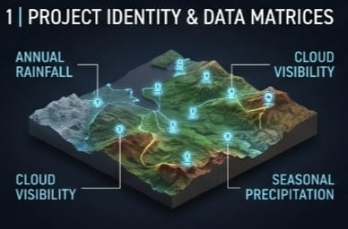

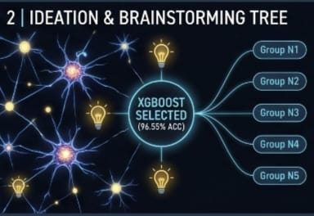

Ideation Phase
Define the Problem Statements
Date | July 2, 2026
Name | Gundigi Poojitha
Project Name | Rising Waters: A Machine Learning Approach to Flood Prediction
Maximum Marks | 2 Marks
—————————————————————————————————————————————————————————————————
I AM | A Disaster Relief Coordinator or Meteorologist tasked with preserving community safety and optimizing emergency protocols in highly flood-prone districts.
I'M TRYING TO | Accurately anticipate impending flash-floods and strategically coordinate essential resource allocations or evacuation maps prior to severe downpours.
BUT | Conventional forecasting technologies often fall short in delivering timely, granular, or high-accuracy actionable early localized warnings.
BECAUSE | Vast multi-variable environmental features—such as regional cloud visibility metrics, specific annual metrics, and shifting localized seasonal precipitation data—are not synthesized dynamically by legacy predictive tools.
WHICH MAKES ME FEEL | Deeply anxious regarding potential lapses in response agility, misdirected emergency resource distribution, and avoidable vulnerabilities to human lives and local livelihoods.

Ideation Phase
Empathize & Discover — Empathy Map
Date | July 2, 2026
Name | Gundigi Poojitha
Project Name | Rising Waters: A Machine Learning Approach to Flood Prediction
Maximum Marks | 4 Marks
—————————————————————————————————————————————————————————————————
••• THINKS & FEELS •••  • Is our localized dataset reliable enough to order a full district evacuation?  • How can we replace slow legacy statistical setups with dynamic automated analytics?  • Stressed by recurring flood devastations and shifting extreme climate patterns. | ••• HEAR •••  • Traditional meteorology charts fail to alert remote districts effectively.  • Multi-region field teams claim coordinate timing gaps create severe relief deployment bottleneck constraints.  • Cloud systems offer excellent multi-location scaling models.
••• SAYS & DOES •••  • Manual cross-referencing takes hours during critical downpours.  • Coordinates assets placement maps live based on real-time precipitation inputs.  • Enforces strict data preprocessing checklists to handle outliers gracefully. | ••• SEE •••  • Complex environmental logs and historical sheets lacking clear visual reporting metrics.  • High test accuracy validation maps (96.55% test score) reached by XGBoost ensemble code pipelines.  • Simple dashboard panels that render instant safety probability outcomes.

Customer Journey Map
Date | July 2, 2026
Name | Gundigi Poojitha
Project Name | Rising Waters: A Machine Learning Approach to Flood Prediction
Maximum Marks | 2 Marks
—————————————————————————————————————————————————————————————————
Phase of Journey | Stage 1: Pre-Crisis Preparedness | Stage 2: Incident Evaluation | Stage 3: Performance Assessment
Actions | • Analysts pull open-source Kaggle weather matrix files.  • Complete univariate and multivariate box plots. | • Technicians observe heavy monsoons downpours.  • Log parameters like cloud visibility live. | • Defense authorities review system accuracy mappings.  • Confirm optimal 96.55% XGBoost accuracy.
Touchpoint | • Python EDA standalone notebook  • Pandas & Seaborn plot views  • Preprocessing split data arrays | • Flask web app layout panel  • Forecast Parameter form panel  • Result dashboard routing paths | • Serialized pkl model object file  • Model evaluation confusion matrix  • Historical prediction logs registries
Customer Thought | • 'Are these weather parameters normalized?'  • 'Does seasonal rainfall correlate tightly with historical flood disasters?' | • 'Can I get reliable risk outputs in time?'  • 'Is the web server interface responsive enough during emergency shifts?' | • 'Is the tree ensemble classifier stable?'  • 'Does this high precision justify global cloud implementation?'
Customer Feeling | Analytical, focused on ensuring accurate metrics cleaning and feature engineering. | Anxious due to incoming monsoons, but reassured by sub-second inference speed responses. | Confident in the selected pipeline's capability to safely command proactive field assets deployment.
Process Ownership | Government Environmental Data Specialist | District Meteorologist / Response Coordinator | Senior Civil Protection Compliance Authority
Opportunities | Automate missing data replacement logic and deploy database connections to stream weather updates directly. | Integrate automatic sensor inputs telemetry modules and link automated SMS warning alerts to results view panels. | Deploy distributed scaling clusters on IBM Cloud and build automated container retraining schedules.

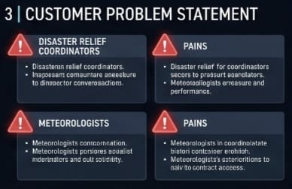

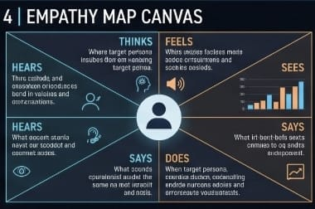

Data Flow Diagram & User Stories

User Stories Matrix Log
Date | July 2, 2026
Name | Gundigi Poojitha
Project Name | Rising Waters: A Machine Learning Approach to Flood Prediction
Maximum Marks | 4 Marks
—————————————————————————————————————————————————————————————————
User Type | Functional Requirement (Epic) | User Story / Task Description | Acceptance Criteria | Priority
Meteorologist | Weather Data Prep | As an operator, I can input localized rainfall metrics so the backend passes them to feature arrays. | Inputs compile securely without latency. | High
Coordinator | Disaster Alerting | As a safety coordinator, I can view distinct 'Flood Chance' or 'Safe'结果views to command deployments. | System directs output paths to correct status screen. | High
Data Analyst | Performance Validation | As an analyst, I can test the classifier against historical records to monitor validation parameters. | Confusion matrix shows over 96% classification precision. | Medium
Field Operator | Inference Records Log | As an operator, I can look at past prediction registries on a clear history viewport grid table. | History screen populates accurate rows sequentially. | High
Administrator | Platform Scaling | As an administrator, I can migrate application execution environments onto hosted container slots. | Web application operates natively inside IBM Cloud. | Medium

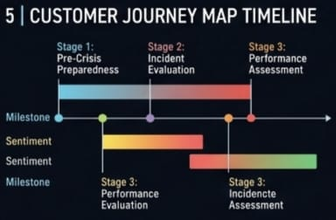

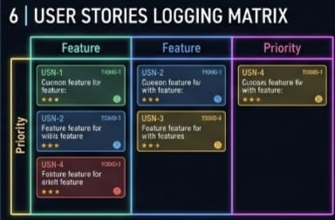

Solution Requirements
Date | July 2, 2026
Name | Gundigi Poojitha
Project Name | Rising Waters: A Machine Learning Approach to Flood Prediction
Maximum Marks | 4 Marks
—————————————————————————————————————————————————————————————————
Functional Requirements:
Forecast Parameters Form Panel | Captures numeric input vectors (including annual rainfall and visibility indices) entered by administrators.
XGBoost Core Inference Service | Invokes the underlying serialized pipeline configuration array object to run classification calculations.
Dynamic Hazard View Router | Directs dashboard output screens asynchronously to show explicit safe views or high risk alerts layouts.
Prediction Logs Storage Engine | Appends submitted features along with evaluation timestamps into a centralized dashboard history tracking grid.
Platform Integration Wrapper | Loads serialized dependencies assets (`xgboost_flood_model.pkl`) seamlessly during Flask application boot loops.
Non-Functional Requirements:
Usability | Dashboard layout must apply responsive UI elements ensuring cross-browser access without operational training.
Reliability | The application logic must return consistent, high-precision outcomes aligned with our 96.55% test verification baseline.
Performance & Speed | API processing, parameter matrix scaling, and model calculation must complete page updates within < 2 seconds.
Availability | System engine architecture must stay accessible 24/7 with minimal downtime parameters during monsoon tracking windows.
Scalability | Core logic routines must seamlessly scale inside container targets to handle concurrent regional monitoring connections.

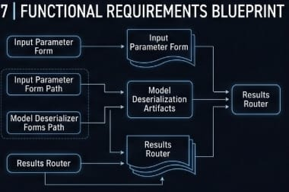

Technology Stack
Date | July 2, 2026
Name | Gundigi Poojitha
Project Name | Rising Waters: A Machine Learning Approach to Flood Prediction
Maximum Marks | 4 Marks
—————————————————————————————————————————————————
Technical Architecture Stack Profile:
Component Layer | Description | Technology Implementation
User Interface (Frontend) | Provides a fully clean and responsive interface for tracking configurations and rendering results. | HTML5, CSS3, Vanilla JavaScript, Bootstrap
Application Routing Backend | Manages endpoint queries execution, intercepts POST inputs, and structures local vector scaling. | Python, Flask Web Framework
Pre-processing & Math Arrays | Manages missing entries cleaning, handles data scaling operations, and arranges vector shapes. | Pandas, NumPy, Scikit-learn Pipeline
Machine Learning Core Engine | Loads structural matrices configurations to run real-time hazard probability evaluations. | XGBoost Classification Library
Model Artifact Persistence | Serializes compiled tree coefficients into standalone byte code storage objects natively. | Python Pickle / Joblib Serializer

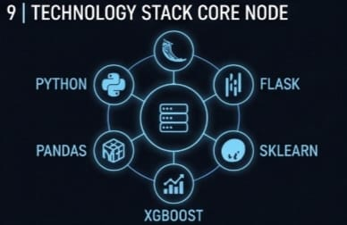

Project Design Phase
Proposed Solution Parameters Outline
Date | July 2, 2026
Name | Gundigi Poojitha
Project Name | Rising Waters: A Machine Learning Approach to Flood Prediction
Maximum Marks | 2 Marks
—————————————————————————————————————————————————
Problem Statement Definition | Legacy structural methodologies ignore non-linear multi-variable climate factors relationships, producing late localized flood warnings during critical downpours.
Idea or Solution Description | Establish an advanced machine learning classification dashboard engine trained over climate metrics using optimized tree structures deployed inside a lightweight Flask frame.
Novelty or Uniqueness | The application incorporates asynchronous preprocessing modules linked directly with a high-accuracy 96.55% XGBoost classifier file object (`xgboost_flood_model.pkl`).
Social Impact & Agility | Provides localized civil defense and emergency crews with actionable predictive results hours in advance, optimizing community safety and evacuation readiness loops.
Scalability & Cloud Vector | Configured layout and component dependencies baseline details explicitly to support easy deployment migration inside hosted IBM Cloud web server environments.

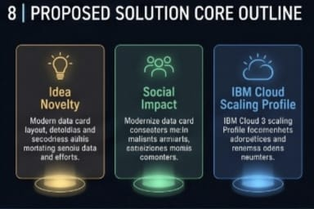
Project Planning Phase
Product Backlog, Sprint Schedule and Estimation
Date | July 2, 2026
Name | Gundigi Poojitha
Project Name | Rising Waters: A Machine Learning Approach to Flood Prediction
Maximum Marks | 5 Marks
—————————————————————————————————————————————————————————————————
Sprint | Epic Category | Task / User Story Description | Story Points | Priority | Assigned | Schedule
Sprint-1 | Environment & EDA | Configure Anaconda Navigator, gather Kaggle weather metrics tables, and design Pandas univariate/multivariate distribution plots. | 3 | High | Gundigi Poojitha | Weeks 1-2
Sprint-1 | Data Engineering | Isolate dataset outliers using Seaborn box maps, manage null items, and perform standard variable feature scaling adjustments. | 2 | High | Gundigi Poojitha | Weeks 2-3
Sprint-2 | Model Training | Train tree ensemble architecture algorithms (Decision Tree, Random Forest, KNN, XGBoost) and record confusion matrix logs. | 4 | High | Gundigi Poojitha | Weeks 3-4
Sprint-2 | Selection & Save | Isolate optimal 96.55% accurate classifier pipeline configuration and export code logic parameters inside a secure file artifact. | 2 | High | Gundigi Poojitha | Week 4
Sprint-3 | Flask UI Assembly | Construct responsive Flask app web server script code, compile split views elements, and verify deployment scripts under local host routing loops. | 3 | High | Gundigi Poojitha | Weeks 5-6

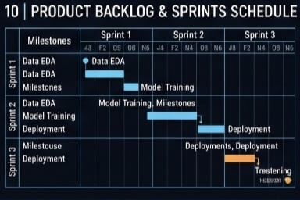

Code-Layout, Readability and Reusability Specifications
Date | July 2, 2026
Name | Gundigi Poojitha
Project Name | Rising Waters: A Machine Learning Approach to Flood Prediction
Maximum Marks | 5 Marks
—————————————————————————————————————————————————
S.No | Code Parameter | Implementation Strategy Details | Followed (Yes/No)
1 | Consistent Indentation | Enforced uniform four-space Python PEP 8 indentation standards across both data training pipelines notebooks and production backend scripts. | Yes
2 | Proper File Structure | Organized workspace into clear dedicated directory slots separating data records (`data/`), models binary (`model/`), and web view panels (`templates/`). | Yes
3 | Meaningful Naming Rules | Descriptively named variables mapped directly to targeted meteorological indicators, such as `annual_rainfall` and `cloud_visibility` parameters. | Yes
4 | Code Comments | Documented internal data pipeline scaling modules and serialized tree classifier wrapper arrays using clean inline blocks and explicit docstrings. | Yes
5 | Modular Architecture Strategy | Maintained loose coupling separation dividing exploratory statistics routines, training pipeline execution rules, and web presentation layer modules. | Yes

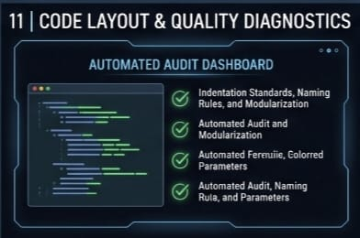

Coding and Solution Portfolio Report
Date | July 2, 2026
Name | Gundigi Poojitha
Project Name | Rising Waters: A Machine Learning Approach to Flood Prediction
Maximum Marks | 5 Marks
—————————————————————————————————————————————————
Programming Languages Baseline | Python, HTML5, CSS3, Vanilla JavaScript
Frameworks & Core API Libraries | Flask Application Server Engine, XGBoost Ensemble Toolkit, Scikit-learn Pipeline Framework, Pandas Processing Library, NumPy Array Engine
Key Functional Features Implemented | Asynchronous meteorological cleaning matrix, data shape standardizer pipeline helper, serialized model file loader, local host view router handlers code configurations.
Pending / Future Roadmap Upgrades | programmatically connecting hardware IoT sensor telemetry nodes, enabling automated multi-language view support, and autoscaling containers deployment on IBM Cloud.
Local Host Installation Guidelines | 1. Clone workspace: git clone https://github.com/gautham-ganesh/rising-of-waters  2. Open root folder and install package packages: pip install -r requirements.txt  3. Launch web server script: python app/app.py  4. Load browser view: navigate local dashboard to http://127.0.0.1:5000

Project Executable Files Specification Document
Date | July 2, 2026
Name | Gundigi Poojitha
Project Name | Rising Waters: A Machine Learning Approach to Flood Prediction
Maximum Marks | 3 Marks
—————————————————————————————————————————————————
Architecture Layer | Workspace Location Parameters
Repository Link Access | https://github.com/gautham-ganesh/rising-of-waters
File System Folder Map Layout | flood-prediction-system/  ├── data/ # flood_dataset.csv historical climate tables  ├── notebooks/ # model_training.ipynb EDA and scikit pipeline grids  ├── model/ # xgboost_flood_model.pkl serialized best model artifact  └── app/ # static/ style assets, app.py main web routing orchestration script
Demo link | https://rising-of-water.onrender.com/
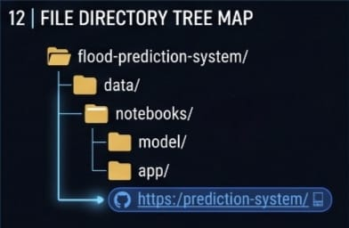

Result of the Project

